GRANARD MUNICIPAL DISTRICT

Corporate Affairs,
Aras an Chontae,
LONGFOIRT.

21st February 2017.

To: Each Member of Granard Municipal District.

Dear Member,

You are requested to attend Meeting of Granard Municipal District to be held in
Granard Community Library on Tuesday, 28th February 2017 as follows –

- 4.00 p.m. - Meeting of Municipal District to consider and approve
Schedule of Granard Municipal District Works – report enclosed

Yours sincerely,
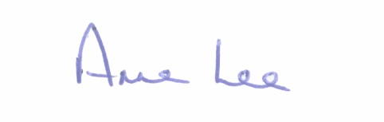

_______________
Anne Lee,
Meetings Administrator.

